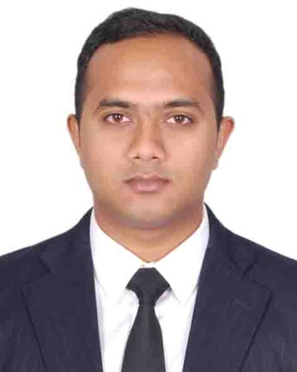
Saqeeb Rahman
301, Shamoli, Dhaka,
E-mail: saqeebworld@msn.com
Phone: 01672-697606

OBJECTIVE: Ambitious, energetic student seeking an opportunity to enhance my skills and academic knowledge through valuable work experience.

EDUCATION:
Masters of Business Administration (MBA)
American International University-Bangladesh (AIUB), Dhaka
Major- Marketing
CGPA- 3.30 (scale of 4)
Expected year- 2015

Bachelor of Business Administration (BBA) (2014)
American International University-Bangladesh (AIUB), Dhaka
CGPA- 3.44 (scale of 4)
Major- Human Resource Management

HSC (2010)
Mohammadpur Preparatory Higher Secondary Boys' School
Business Studies
GPA- 3.30

SSC (2008)
Mohammadpur Preparatory Higher Secondary Boys' School
Science Studies
GPA- 4.25

WORK EXPERIENCE:

- Working as an Executive, Sales & Marketing at Asian Holidays,
(1st October, 2014 to 30th September, 2015)
- Responsibilities: Client Service, Advertising & Promotion, Corporate Marketing, Market Research, Marketing, Relationship Management, Sales, Tele Marketing,
- Worked as an Intern of HR at Summit group of Summit power Ltd, (19th Jan to 17th Apr) Year: 2014
- Responsibilities: Employee Database, Management System, Performance Appraisal Process, Employee Recruitment Process, Applicant’s Database Management,

ACHIEVEMENTS:
- Winner of AIUB Marketing Genius (Certificate of Recognition),
(A competition for developing innovative business ideas),

COMMUNICATION SKILLS:
- Proficient in writing and editing reports,
- Experience in giving multimedia presentations,
- Proficient in oral and written communications,
(Bangla and English)

SELF ASSESSMENT:

I have the capacity to work under stress and deadlines. Possess effective leadership abilities.

PERSONAL INFORMATION:

Father : LatifurRahman
Mother : Bulbul Akter
Permanent Address : 301, Shamoli, Dhaka,
Date of Birth : October 22, 1992
Nationality : Bangladeshi

REFERENCE:
Atikul Husain Khan Mohammad MostofaJaman
FORMER DIRECTOR GENERAL Senior Lecturer
BANGLADESH RAILWAY Department of Management & HRM
301, Shamoli, Dhaka Faculty of Business Administration
Contact: 01726-904233 American International University-Bangladesh
Phone: +88-02-8820865

SaqeebRahman
301, Shamoli, Dhaka,
E-mail: saqeebworld@msn.com
Phone: 01672-697606

