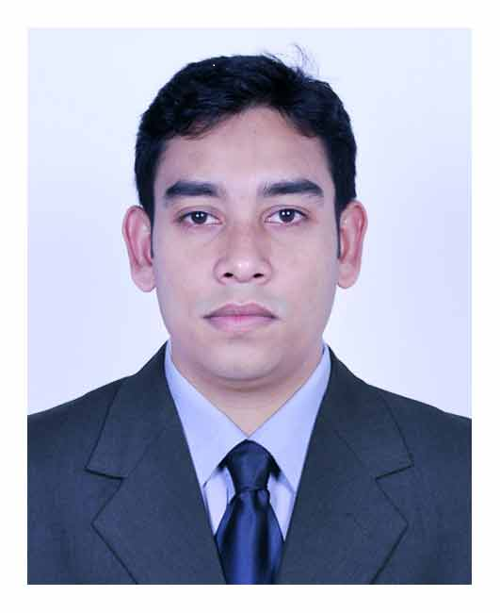
Md. Ashik Iqbal
House # 17, Road 08, Sector # 10,
Uttara, Dhaka-1230.

Mobile No: +8801724325429

E- mail: ashik.iqbal89@gmail.com

Career Summary:
Engineering with more than 5 years of Auto CAD, Site Management and Office management experience. Expertise in Measurement, Check & Quality Control, Supervision & Control of project, Estimating & Costing and Time Schedule Maintain. Create progress reports of construction work performed, to ensure day to day progress report to the top Management, Make progress reports & Bill of works etc, Command site administration. A remarkable experience of working in any Engineering department in different projects.

Career Objective:
I want to be an ideal Engineer with the help of theoretical and practical knowledge. I have been interest in developing my career in such an environment where there would be enough scope for enhancing my knowledge and developing myself.
Work Experience:
Dwelling Development Ltd
Position: Project Engineer (1st May 2013 to continuing)
Binimoy Complex, Ground Floor, Ershadnagar, Tongi, Gazipur.
Job Responsibilities:
- Site supervision, Estimating & Quality Control.
- Checking Electric & Plumbing work (According to drawing).
- Create progress reports of construction work performed.
- To supervise the overall activities & progress of projects.
- Create progress reports of construction work performed.
- To ensure day to day progress report to the top Management.

S.O .Architects
Position: Assistant Project Engineer (1st June 2011 to April 2013)
House # 23 Ground Floor, Road# 10/B, Sector# 11, Uttara Dhaka-1230

Job Responsibilities:
- Site supervision, Bill Preparation, Quality Control.
- Estimating, Time Schedule Maintain.
- Checking Finishing Work, Construction Work.
- Architectural & Working Drawing.
- Section, Elevation and Structural Drawing.
- Checking Electric & Plumbing work (According to drawing).

Brahe & Bestec JV Ltd.
Position: CAD Operator (1st September 2009 to May 2011)
House # 2, Road # 14/A, Sector # 04, Uttara, Dhaka-1230.
Job Responsibilities:
- Architectural & Working Drawing.
- Section. Elevation and Structural Drawing.
- Estimating & Costing.
- Rajuk Plan Pass Drawing.
- Site Visit, Make progress reports.

Educational Qualification:
Exam Title | Major | Institute | Result | Pass Year | Duration
Bachelor of Science in Civil Engineering | Civil Engineering | International University of Business Agriculture and Technology | CGPA:3.20 out of 4 | 2013 | 4 Years
Diploma in Civil Engineering | Civil Engineering | Pabna Polytechnic Institute, Pabna | CGPA:3.33 out of 4 | 2009 | 4 Years
Secondary School Certificate | Building Maintenance | Sujanagar Pilot High School | CGPA:3.86 out of 5 | 2005 | 10 Years
Training Summary:
Training Title | Topic | Institute | Country | Location | Year | Duration
Industrial Attachment | Supervision of construction work | Nagar Home Ltd. | Bangladesh | Dhaka | 2008 | 4 Months
Practicum Internship | Structural Design Of Residential Building | Tarique Hasan and Associates Ltd. | Bangladesh | Dhaka | 2013 | 4 Months
Language Proficiency:
Language | Reading | Writing | Speaking
Bangla | High | High | High
English | High | High | Medium
Computer Skills:
Operating Systems : Windows 7 / XP.
Application Software : MS Word, MS Excel, MS PowerPoint, Adobe Photoshop.
Design Program : Auto CAD, Max, Revit,
Capability : Internet browsing and office works.

Strengths:
- Strong leadership and team building Skills.
- Well versed in business and commercial correspondence as well as writing reports and dealing with multimedia presentations.
- Performing duty in any situation
Personal Detail:
Father : Md. Abdul Azit PR
Mother : Mrs. Helena Khatun
Date of Birth : 12 December, 1989
Marital Status : Single
Blood Group : O+
Nationality : Bangladeshi
Religion : Islam
Height : 5’-6”
Permanent Address : Vill - Krishnopur, P.O & P.S - Sujanagor, Dist - Pabna.
Present Address : House#17, Road#08, Sector#10, Uttara, Dhaka -1230.

References:
 |  | Reference: 01 |  | Reference: 02
Name | : | Engr. Wasil Hasan Chowdhury |  | Prof. Dr. Md. Monirul Islam.
Organization | : | Tarique Hasan and Associates Limited |  | IUBAT - International University of Business Agriculture and Technology
Designation | : | Senior Structural Engineer |  | Chair, Department of Civil Engineering IUBAT
Address | : | House-10, Road-19/a, Block-E, Banani, Dhaka-1213 |  | 4 Embankment Drive Road (Off Dhaka-Ashulia Road) Sector 10, Uttara Model Town, Dhaka 1230, Bangladesh.
Mobile | : | 01714498039 |  | 01716583558
E-mail | : |  |  | rs_gism@yahoo.com

……………….
Md. Ashik Iqbal

